Friends and Places Together– Incident/Accident Report

Part A – to be completed and sent to Chief Officer within 48 hours of incident/accident by (or on behalf of) each person affected by an accident, occupational disease, violence (actual or threat) Please tick all appropriate boxes, leave blank boxes that don’t apply, use a continuation sheet if necessary: Tick here if continuation sheet has been used
Report No: Sarge005

1. Person injured/affected:
X

Danielle Lewis
Name: Gender: Male Female

Home address:
20 Crowstone Road, Westcliff on Sea Essex
Status: Carer Client/Service User
X

2. Incident/Accident details:
1030 230
20 – 21/8/15
Date of incident/accident Time:

Premises/site Exact location:
Camp Site
Stubbers
(eg. room no., kitchen)

3. About the Incident/Accident: What happened? (who was doing what at the time of the accident).
- Whilst Cameron Tamage was tidying the camp area of pegs Danielle was sitting on the bench and walked over to the tents (appx 20ft away) and punched Cameron in the back without any provocation. Cameron started to cry and Danielle walked off as though nothing had happened. On speaking to her she had no recall of her actions, although did make an apology eventually

- Danielle did not join in the activity and stayed in the camp, she was playing with the football and started to throw the ball at the lodge windows. Monique Warburton came out of the lodge and asked her to stop as she could break the glass. Danielle responded by telling her to Fuck off. Monique walked back inside the lodge and Danielle continued to throw the ball at the windows. Monique then came back out and asked her to stop, with which Danielle threw the ball hard at her causing an in-print of the ball to her stomach. Monique called Simon to come from the activity and assist. On Simon entering camp and speaking to Danielle was also told to Fuck off. She then proceeded to throw the ball over the fence into the stinging nettles. Within five minutes later all was calm as though nothing had happened, Steve then arrived on camp and spoke to her and she eventually appologised to Monique. Simon took a photo of the injury. See below.

4. Witnesses name and contact details:

X

Statement(s) attached: Yes No

5. Accident Type (please tick one box only)

moving/handling of object slip/trip/fall on same level violence moving/handling of person

fall from height road traffic collision struck against machinery/equipment

animal contact struck by electrical injury near miss

sharp object awkward movement hot/cold contact hazardous substance

other (please specify)

6. Complete for violent incidents only - Incident details (please tick one box) please tick if person
was not necessarily

X
X
Nature of Incident - Physical assault threat/verbal abuse property damaged responsible for
(inc. telephone and written) their actions

X

Nature of Activity - support/ personal care transporting client other
assisting (please specify)
No

Y
N
Other Factors - was carer/ were police was a weapon some form of prejudice
client alone? involved? used?
N
Y
physical intervention/restraint challenging behaviour
M Warburton, no1 Homestead Court, Hadliegh. SS7 2PB
Details of third party/aggressor involved: Name & Address:

7. If injured:
What part(s) of the body were affected e.g. head, arm (please indicate left or right)
Stomach

If injured detail injury: cut/abrasion bruise burn/scald twist/strain
In print of ball

fracture foreign object other (please specify)

consequences: none first aid received sent to hospital
X
X

any other details: (details of first aid should be included here and records kept locally)
In print of ball to stomach due to how hard the ball was thrown, applied ice to relieve pain.

Steve Mervish/ Simon Sargent
people informed: e.g. next of kin, parents

8.
22/8/15
M Warburton
Signature Date
Staff

If signing on behalf of the affected person please state your: Name Position
1 Homestead Court, Hadleigh, Essex SS7 2PB
Address

PART B - To be completed by the Chief Officer

9. What action has been/could be taken to prevent a re-occurrence?

10. Recommended action to be taken?

11. Staff completing this form

Name signed Job title

(please print)

Office address Tel no. Date

Photographic evidence:

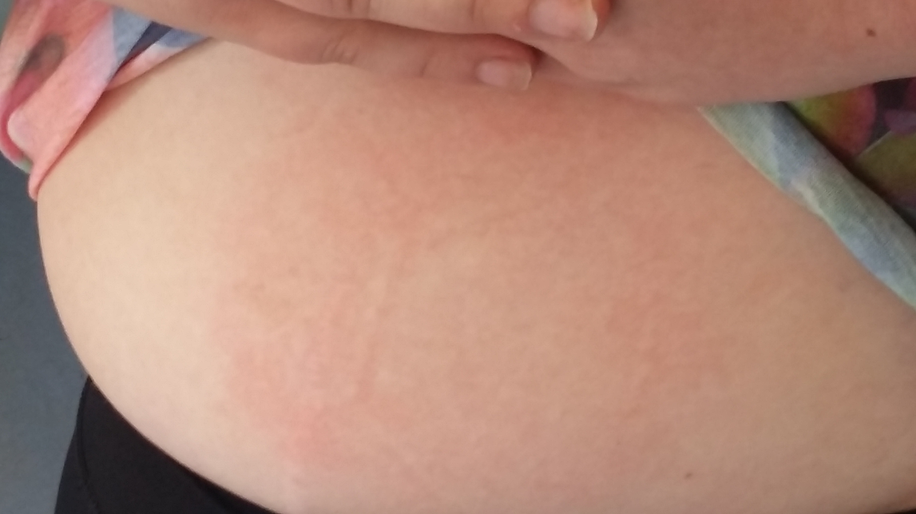 In print of ball

