How to use this matrix for undertaking a risk assessment:
1. Assess the risk identified, what is the risk, who could be injured, what could happen, rate the likelihood and the potential severity. Calculate the rate: Likelihood x Severity
2. Assess how to reduce the risk and re calculate the with controls in place, the Likelihood will change, the severity remains constant. Calculate the rate: Likelihood x Severity
Example: Risk of tipping a wheel chair and user out of the chair.
Initial Likelihood off 4, Severity 4 – Rate = 16
Controls in place – Likelihood 2, Severity 4 – Rate = 8
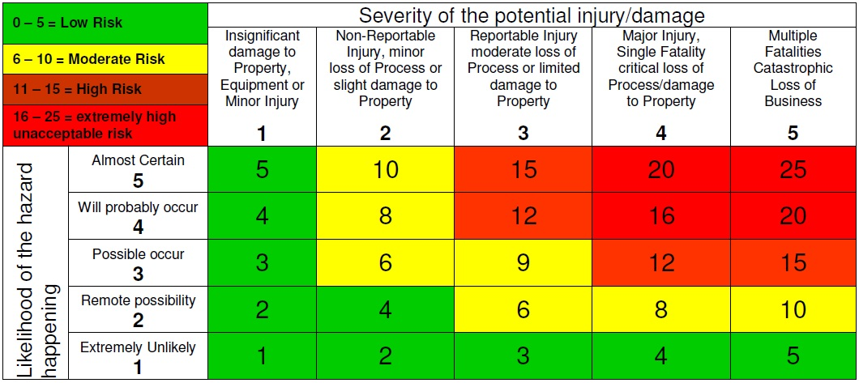

Risk / Task | Hazards | Person’s affected | Outcome | Level of Risk |  |  | Control Measures | Level of Risk |  |  | Assessment by | Review date
 |  |  |  | L | S | R |  | L | S | R
Use of Wheelchair | Tipping, Falling, Sudden Stop | Wheelchair User, Carer, Public | Graze, Cut, Bruising, Broken Bone | 4 | 3 | 12 | Ensure user is strapped in/ use harness.  Be aware / check surface for unevenness.  Use foot bar to tilt chair for kerb.  Hold handle firmly whilst pushing. | 1 | 3 | 3 | SC Sargent

